BOARD OF DIRECTORS

President
Michael Huey DMD
Endodontist

Vice President
Gary Foss
Boeing Technical Fellow, Ret.

Secretary
Amy Heidner
Educator

Treasurer
Caroline Stein
Consultant

Fair Director
Lois Jane Lugg
Electrical Engineer

WSSEF Founder
Gwen Croswaite
Emeritus

Kandis Foley
Home School Coordinator

Charles Fritz
Systems Analyst

Raymond Koelling
Research Scientist

James Luddon, Jr.
Professional Engineer, Ret.

Bruce Murdock
Science Educator, Ret.

Pam Odam
Electrical Engineer, Ret.

Mary Omberg
Educator, Ret.

George Phillips
Software Engineer, Ret.

Todd Rosenfelt
Aerospace Sr. Eng. Project Mgr.

Dr. Shuttha Shutthanandan
Research Scientist

Warren Spalinger
Nuclear Engineer
___________________

Endorsements:
Washington Superintendent of Public Instruction (OSPI)

American Association for the Advancement of Science (AAAS)

Washington State Academy of Sciences (WSAS)

WA Association of School Administrators (WASA)
___________________

Affiliate:
Intel International Science
& Engineering Fair (ISEF)
___________________

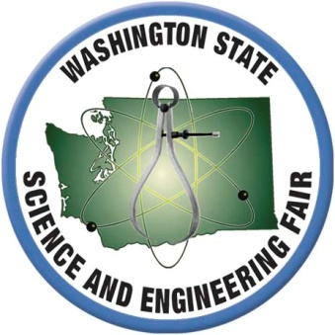
For Immediate Release
Contact Info: www.wssef.org
WSSEF Media publicity@wssef.org

Local Student attends Washington State Science and Engineering Fair

Local [your student’s grade here]-grade student [your student’s full name here] was among the more than 600 presenters at the 62nd Annual Washington State Science and Engineering Fair (WSSEF www.wssef.org) in Bremerton on March 29 & 30, 2019. Students from first through twelfth grades converged on Bremerton High School with their project boards and demonstration materials.

[Your student’s name here], from [your student’s school here], presented the project “[your student’s project title here]” to judges who volunteer their time to listen, critique and praise the students. WSSEF awards more than $1.8 million in scholarships as well as special awards meeting specific criteria set by a sponsor.
[Optional: insert short description of your student’s project here.]

At the 2019 WSSEF, [your student’s name here] earned a [name of award here]. This is her/his [first/second/etc.] year of participation.

WSSEF is an all-volunteer non-profit organization dedicated to promoting science, technology, engineering and math across the state year-round.

This year’s Major Sponsors include: The Boeing Company, Olympic College, City of Bremerton, Johns Hopkins University, Bremerton School District, Bonneville Power Administration, GoDaddy, Kitsap County, Baymont Inn & Suites Bremerton, Eureka Masonic Lodge #20 F&AM, Helix Creative Services, Wolfram Research, Inc., Ohio Wesleyan University, Embry Riddle Aeronautical University, Washington State University – College of Arts and Sciences, Washington State University – Voiland College of Engineering and Architecture, The Evergreen State College, Whitman College, Seattle Pacific University, DELL/EMC2 and DuPont Pioneer.

This letter confirms that no portion of funds are used for lobbying and that as a 501(c)3 non-profit your donation is tax deductible to the extent allowable by law.

